I’ve compiled my thoughts below in blue for certain excerpts of the letter from CEMEX. Because the letter was scanned, it was difficult to capture the text directly, so I pasted images in from the document itself.

Continued cement plant operations are not contingent upon continued mining at Dowe Flats, as the permit at issue does not pertain to the cement plant operation.
The mining permit cited in the Town's comment —M-1977-208 —pertains to mining operations on property surrounding the cement plant south of SH 66 and known as the Lyons Mine (or Lyons Quarry), where mining operations have ceased, and reclamation is ongoing. The Dowe Flats quarry operates north of SH 66 under mining permit M1993-041. It is the Dowe Flats quarry that is the subject of the pending application.

The letter from the State of Colorado Division of Minerals and Geology included by the Town in its support of expedited reclamation of the cement plant does not pertain to cessation of mining and subsequent reclamation at Dowe Flats. It pertains to cessation of mining operations at the Lyons Quarry. Moreover, after acknowledging the County's confirmation that the cement plant operates as a nonconforming use, the letter provides that the cement plant becomes subject to reclamation under the permit for Lyons Quarry (not Dowe Flats) only after the cement plant is no longer in operation. (“It appears that once the facility is no longer in operation, the nonconforming use will terminate and be subject fo reclamation under DMG permit M-1977-208.”)
Notwithstanding its entitlement to continued cement plant operations, CEMEX has offered the concession of an accelerated termination of cement plant operations if the SUP for Dowe Flats is extended as proposed in the application. We believe that proposing cessation of cement plant operations at a date certain to coincide with the cessation of mining at Dowe Flats at the end of the requested 15-year-period, despite no permitting or other obligation to do so, helps resolve any misperceptions around this issue and provides certainty to all stakeholders. This certainty should facilitate future regional and local planning.

BL:
1. The definition of pertains in law means: “belong to something as a part, appendage, or accessory.”

2. The Dowe Flats Special Use Mining Permit extension absolutely is a part, appendage or accessory to the cement plant. Under Boulder County regulations, the processing facility for a mining operation must be located within 1,000 feet of the mining operation. Thus, the very existence and validity of this Special Use Permit depends on a nearby cement plant.

3. According to the Division of Reclamation, Mining and Safety (DRMS), the permit M-1977-208 for Lyons Quarry covers the plant operation and future plant site reclamation plans. Reclamation of the plant would need to occur upon cessation of all “mining activities.” According to the DRMS, the only remaining “mining activity” from M-1977-208 still occurring at Lyons Quarry is the plant’s processing of materials mined from Dowe Flats. Therefore, if Dowe Flats mining ceased, then all “mining activities” under M-1977-208 would have then ceased, thus triggering the mandate to demolish and reclaim the plant and return it to pastureland in accordance with the reclamation plan.

DRMS:
“The approved reclamation plan for the Lyons Quarry mining permit (M-1977-208) includes eventually removing the plant and reclaiming the site to pastureland. A mining permit is issued by our office for the full life of the mine (from development and mining through reclamation), with no deadlines for completing mining at the site. Once mining activities have completed, Rule 3.1.3 requires that reclamation be carried to completion by the operator with all reasonable diligence, and each phase of reclamation be completed within five years from the date that mining has ceased, unless extended by the Division. The five-year period may be applied separately to each phase as it is commenced throughout the life of the mine.
For this site, mining activities are still occurring with the processing of material mined from the Dowe Flats Mine. If mining at the Dowe Flats Mine were to cease, that would have implications on the Lyons Quarry permit.

If mining were to cease at the Dowe Flats Mine, we would need to have discussions with the operator regarding their future plans for the Lyons Quarry plant. If they plan to continue operating the plant (without Dowe Flats), they will most likely need to revise the mine permit. The permit can be revised through submittal of a Technical Revision or Amendment application, depending on what they propose. A proposed change in post-mining land use (e.g., from rangeland to industrial/commercial - to leave the plant for final reclamation) and/or a significant change to the reclamation plan must be reviewed through the Amendment process. The review period for a 112c permit Amendment application is 90 days. However, the operator can request extensions of the initial decision date, and it is not uncommon for the review period to take several months longer.
Notice of an Amendment application is sent to various local, state, and sometimes federal agencies (this would include the county and any municipalities located within 2 miles of the site). Notice of the application is also sent to landowners and adjacent landowners. Additionally, the operator must place notice sign(s) at the mine site, place a copy of the application for public review with the County Clerk and Recorder's Office, and publish a newspaper notice in the locality of the mine site once a week for four consecutive weeks.
The public comment period for a 112c Amendment application begins when the application is filed, and ends 20 calendar days after the date of the last newspaper publication. There is no public comment period for Technical Revisions.
To learn more about the public notice procedures for an application, I would recommend reading our Construction Materials Rule 1.6. I'm attaching a copy of these rules for your convenience (you can also view/download them from our website at https://drms.colorado.gov/rules-and-regulations).”

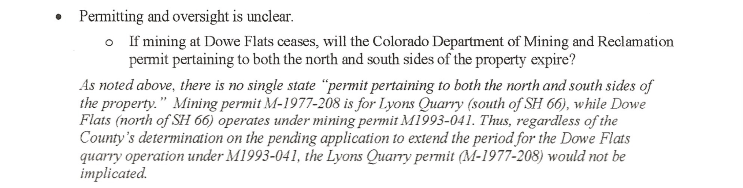

BL: Yes, there are 2 distinct permits from DRMS, which DRMS recommended be joined together given that Dowe Flats and the Plant are fundamentally intertwined. However, based on DRMS statements, I strongly disagree that M-1977-208 “would not be implicated.” In fact, the DRMS says the exact opposite, per the communication above!

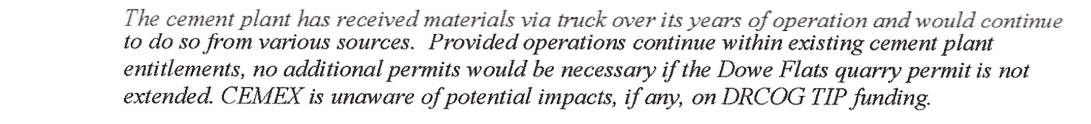

BL: I’ve checked the records available publicly, and they have received materials via truck (some clinker, silica, gypsum, etc). However, the amount is a few orders of magnitude smaller (thousands of tons per year) in comparison to the amount of material we’re contemplating in a future scenario now (hundreds of thousands of tons annually)

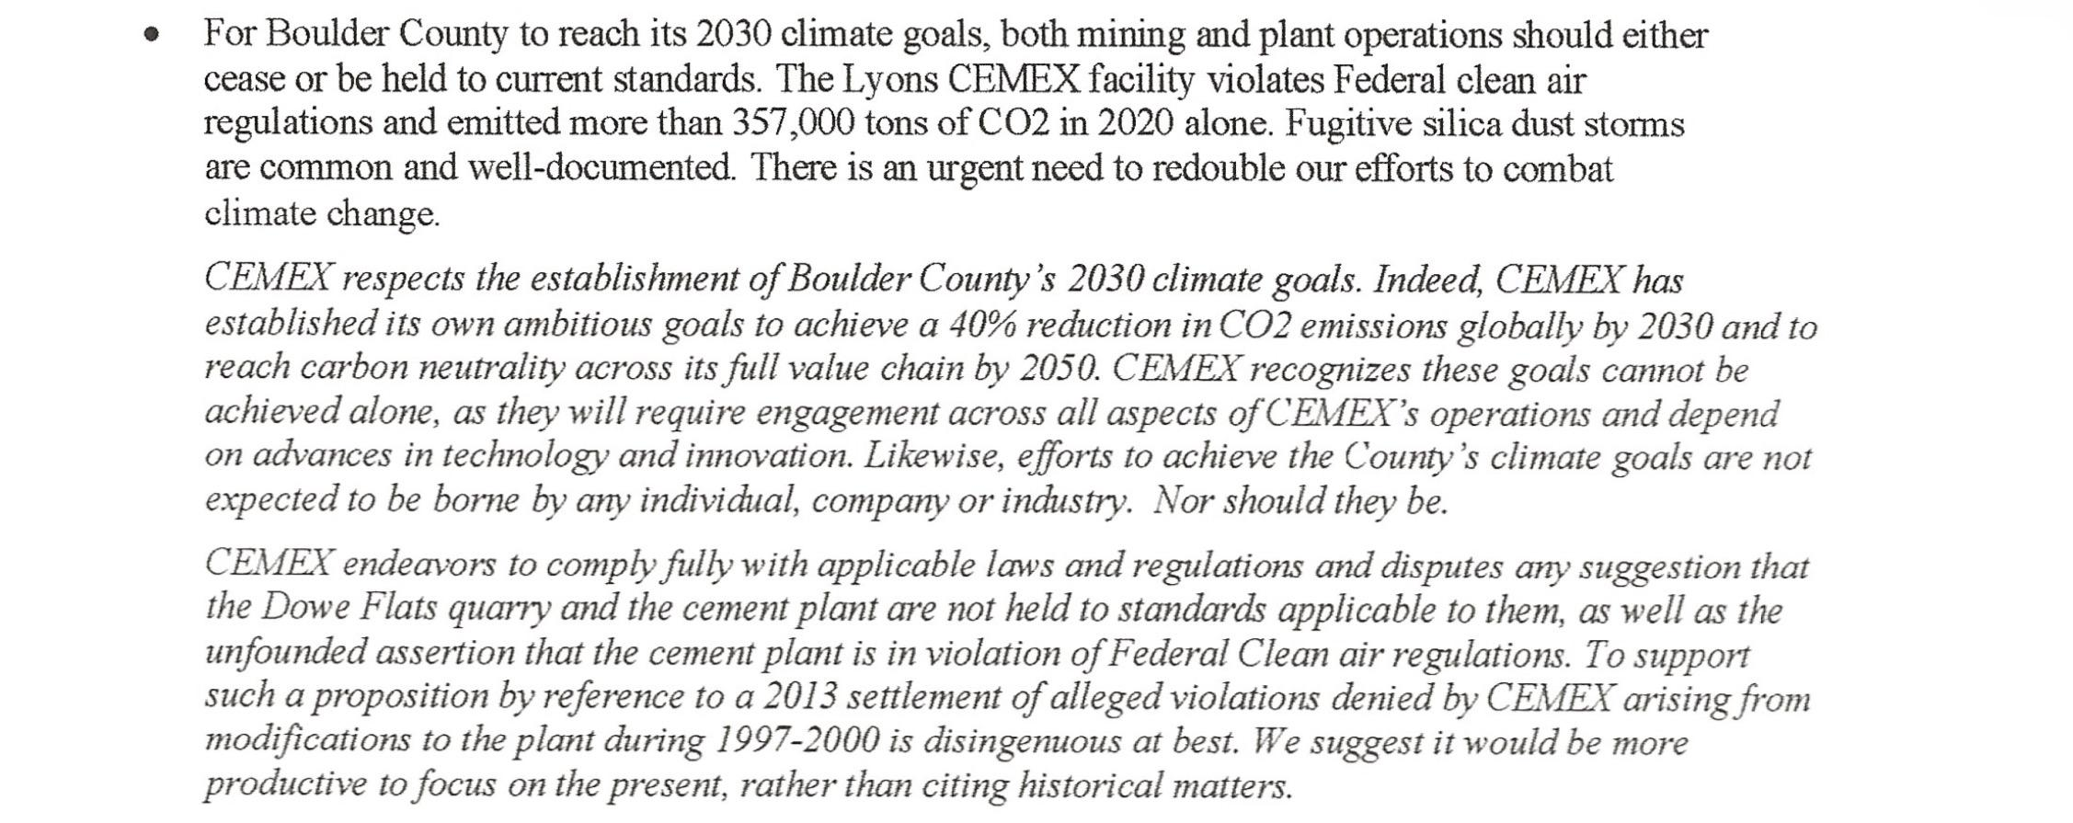

BLL: Agree that the achievement of climate goals cannot be achieved alone. However, CEMEX is the #1 C02 Emitter in all of Boulder County…so it’s logically a good place to start!
As for the present, let’s also talk about the seemingly increasing frequency in the # of the fugitive dust events. In the Referral response, Boulder County Department of Health made a number of requests for modifications and upgrades to the plant.
Also - I can’t recall who relayed to me that they were told by the Plant Manager that the Plant chooses to simply pay fines for violations instead of fixing the underlying cause. I believe we can pull the fine/violation history.

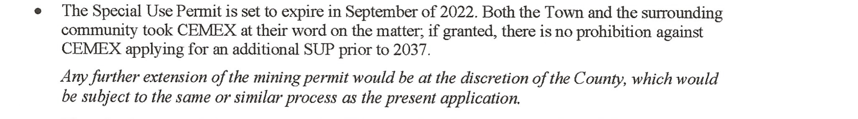

Not a particularly reassuring response. I interpret this as “You’re right, we could in fact apply for another extension in 2037 to dig deeper into the mine or to let the plant continue running and we will do our best to keep our options open“

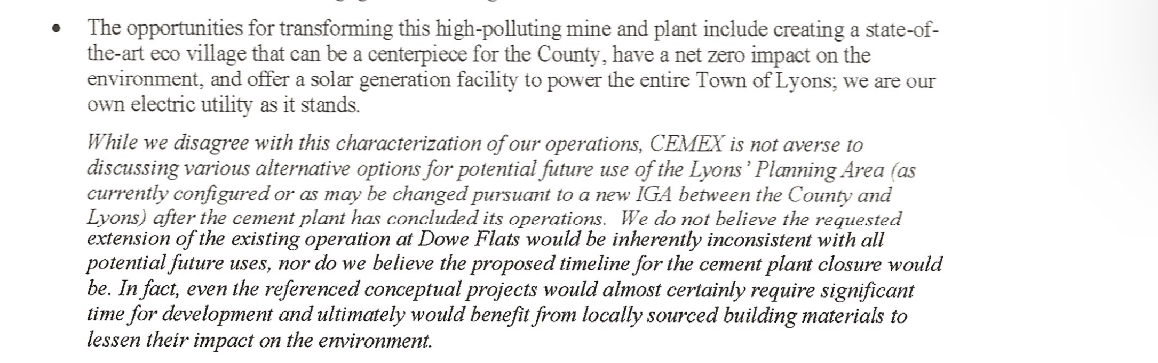

I interpret this as “We’re open to some negotiations about the future of the site”
Finally, I think it’s very important what is NOT stated in this letter. CEMEX could have chosen to provide specifics on their contingency plan in the “indefinite” scenario - in order to bolster their negotiating position. But, they have chosen not to do that, instead dealing in vague generalities, conditionals and qualifying statements.

In addition to how long they could/would operate the cement plant without Dowe Flats, there are several things that are “indefinite” about the “indefinite” plan
- It’s indefinite what DRMS would do with/about the M-1977-208 permit absent Dowe Flats.
- It’s indefinite when the Air Quality Permit would be approved. Given how extensively Dowe Flats is discussed in this permit as the material source, this permit would also require substantial modifications as well.
- It’s indefinite where they would be sourcing raw material.
- It’s indefinite how they would be transporting it and what route it would take.
- It’s indefinite how long they could operate profitably without a local mine.

